**16-BIT DIVISION**

**EXP NO: 8**

**AIM:** To write an assembly language program to implement 16-bit divided by 8-bit using 8085 processor.

**ALGORITHM:**

1. Read dividend (16 bit)
2. Read divisor
3. count <- 8
4. Left shift dividend
5. Subtract divisor from upper 8-bits of dividend
6. If CS = 1 go to 9
7. Restore dividend
8. Increment lower 8-bits of dividend
9. count <- count - 1
10. If count = 0 go to 5
11. Store upper 8-bit dividend as remainder and lower 8-bit as quotient
12. Stop

**PROGRAM:**

LDA 8501

MOV B,A

LDA 8500

MVI C,00

LOOP:CMP B

JC LOOP1

SUB B

INR C

JMP LOOP

STA 8503

DCR C

MOV A,C

LOOP1: STA 8502

RST 1

**INPUT:**

**3,14**

**OUTPUT:**

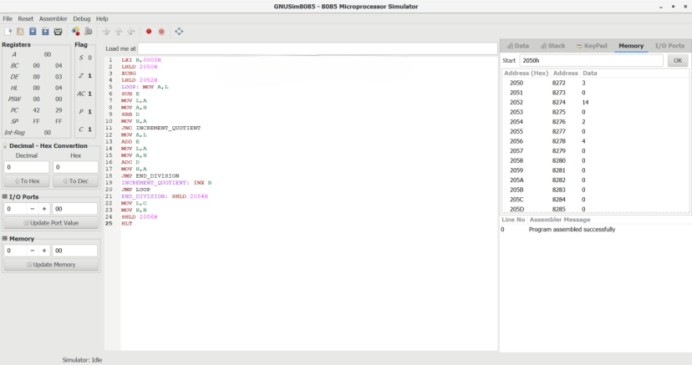

**RESULT:** Thus the program was executed successfully using 8085 processor simulator.